Housing Prices

Anna Olena Zhab'yak, Michele Maione

**Summary** –

# Introduction and description of the problem

Besides that, the constructed house price model can improve the growth of the real estate market

For choosing the regularization parameter in practice, cross-validation (CV)is widely used.

# Most important related works

<https://openreview.net/pdf?id=HklRwaEKwB>

Our work is connected to prior works on ridge regression in high-dimensional statistics (Serdobol-skii, 2007) and wireless communications (Tulino & Verd ́u, 2004; Couillet & Debbah, 2011). Amongother related works, El Karoui & K ̈osters (2011) discuss the implications of the geometric sensitivityof random matrix theory for ridge regression, without considering our problems. El Karoui (2018)and Dicker (2016) study ridge regression estimators, but focus only on the risk for identity covari-ance. Hastie et al. (2019) study “ridgeless” regression, where the regularization parameter tends tozero.

# Notation and relevant definitions

## 3.1 Linear regression

**linear regression** is a [linear](https://en.wikipedia.org/wiki/Linearity) approach to modelling the relationship between a scalar response (or [dependent variable](https://en.wikipedia.org/wiki/Dependent_variable" \t "_blank)) and one or more [explanatory variables](https://en.wikipedia.org/wiki/Explanatory_variable" \t "_blank) (or [independent variables](https://en.wikipedia.org/wiki/Independent_variable" \t "_blank)). The case of one explanatory variable is called [simple linear regression](https://en.wikipedia.org/wiki/Simple_linear_regression" \t "_blank). For more than one explanatory variable, the process is called **multiple linear regression**.[[1]](https://en.wikipedia.org/wiki/Linear_regression#cite_note-Freedman09-1) This term is distinct from [multivariate linear regression](https://en.wikipedia.org/wiki/Multivariate_linear_regression), where multiple correlated dependent variables are predicted, rather than a single scalar variable.

yi= w0 + w1(xi) + ei

where w0 is the intercept of the line and w1 is the slope;

ols

ei is the error and we assume E(ei)= 0 that is each predicted point is equally likely to be above or below the true value, so it is random noise. is the distance from our specific observation back down to the line

E[rt'] = O2I

 the relationships are modelled using [linear predictor functions](https://en.wikipedia.org/wiki/Linear_predictor_function) whose unknown model [parameters](https://en.wikipedia.org/wiki/Parameters" \t "_blank) are [estimated](https://en.wikipedia.org/wiki/Estimation_theory" \t "_blank) from the [data](https://en.wikipedia.org/wiki/Data).

the prediction is formed by the linear function computed in the given data point xi.

The linear predictor for is a linear function

each parameterized by a vector w∈Rd of real coefficients. That is h(x) =w>x.

the feature is how does the median value price change if one feature is changing, having everything else constant

Use **matrix notation** for deriving the linear predictor

Each observation can be rewritten as an inner product between two vectors, w and h(x).

yi = ∑wjhj(xi) + ei

In case of multiple dimensions of the matrix features the line becomes a hyperplane

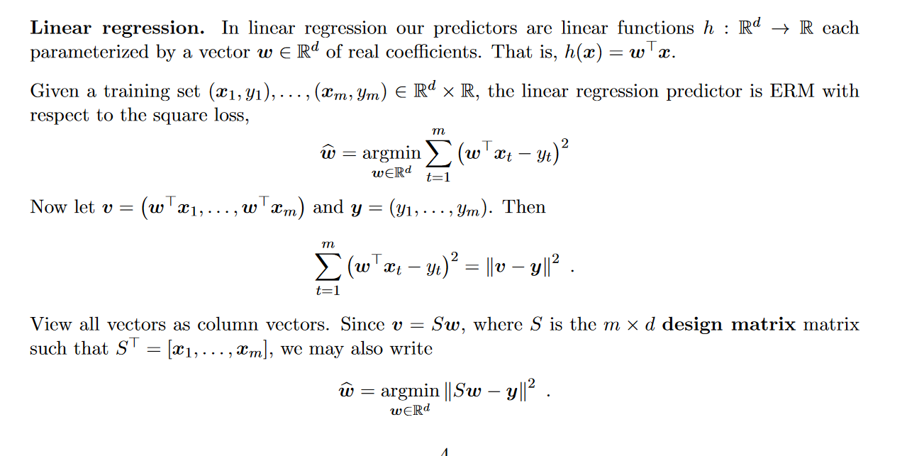



**Loss function**

which measures how different the prediction y ^ {\displaystyle {\hat {y}}} of a hypothesis is from the true outcome y . {\displaystyle y.} The [risk](https://en.wikipedia.org/wiki/Risk_(statistics)) associated with hypothesis h ( x ) {\displaystyle h(x)} is then defined as the [expectation](https://en.wikipedia.org/wiki/Expected_value) of the loss function:

The **loss function** maps an [event](https://en.wikipedia.org/wiki/Event_(probability_theory)) or values of one or more variables onto a [real number](https://en.wikipedia.org/wiki/Real_number) intuitively representing some "cost" associated with the event.

it is used for [parameter estimation](https://en.wikipedia.org/wiki/Parameter_estimation), and the event in question is some function of the difference between estimated and true values for an instance of data.

We use a nonnegative loss function to measure the discrepancy $l\left(y,\hat{y}\right)$ between the predicted label $\hat{y}$ and the correct label $y$.

In the regression task we define the quadratic loss

That is the squared distance between y and y hat. $$l\left(y,\hat{y}\right)={\left(y-\hat{y}\right)}^{2}$$

When $\hat{y} = y$ then $l\left(y,\hat{y}\right)=0$; If $\hat{y} – y = c$ $∀c∈R^{+}$ and *c* is large, then also $l\left(y,\hat{y}\right)$ will be large.

The risk function $R\left(y,\hat{y}\right)$, or the expected loss, becomes the mean squared error of the estimate with respect to the probability distribution

$$R\left(y,\hat{y}\right)=E{\left(y-\hat{y}\right)}^{2}$$

L2 Loss [Mean Square Error (MSE)](https://medium.freecodecamp.org/machine-learning-mean-squared-error-regression-line-c7dde9a26b93) is the most commonly used regression loss function.

in regression we refer to the estimation of a probability density as the loss function as the eucleadian distance in a function space $f∈R^{n×d}$, ideed:

$L\left(f,\hat{f}\right)={\left\|f-\hat{f}\right\|}_{2}^{2}$

And the risk function becomes the squared distances between our target variable and predicted values

$$R\left(f,\hat{f}\right)=E{\left\|f-\hat{f}\right\|}^{2}$$

## Empirical Risk Minimization

It’s a principle that defines a family of algorithms of learning and it’s used to give theoretical limits to their performance. The risk is how well an algorithm will work in practice, because we don’t know the distribution of the data that it will work on, but we can measure the performance on a training test, that is the empirical risk.

So it is the learning algorithm that outputs some predictor in F minimizing the training error.

$$\hat{f}∈{argmin}_{f∈F}\hat{l}\left(f\right)$$

where $F$ is a set of predictors $\hat{y}$ and $l$ is the loss function.

*empirical risk minimizer is a function $f∈F$*

We also assume that we are given a non-negative real-valued [loss function](https://en.wikipedia.org/wiki/Loss_function) L ( y ^ , y ) {\displaystyle L({\hat {y}},y)}

R ( h ) = E [ L ( h ( x ) , y ) ] = ∫ L ( h ( x ) , y ) d P ( x , y ) . {\displaystyle R(h)=\mathbf {E} [L(h(x),y)]=\int L(h(x),y)\,dP(x,y).}

The empirical risk minimization principle states that the learning algorithm should choose a hypothesis h ^ {\displaystyle {\hat {h}}} which minimizes the empirical risk:[[1]](#footnote-1)

*TEST Error*

$\frac{1}{n}\sum_{t=1}^{n}{l}(y_{t}^{'}$, $f\left(x^{'}t\right))$

training error

$$\hat{l}\left(f\right)=\frac{1}{m}\sum_{t=1}^{m}{l\left(y_{t},f\left(x_{t}\right)\right)}$$

Where high complexity models could have very low bias, but high variance.

Whereas low complexity models have high bias, but low variance.

## Ridge Regression

We start from the classic linear regression model

$$y_{i}={\overline{x}}_{i}^{⊤}w$$

Let be the data domain $X∈R^{d}$ and

$$x=\left(x_{1},…,x_{d}\right)$$

let $S$ be the regressor matrix matrix $S∈R^{n×d}$ with $d$ features and $n$ observatios $x_{i}^{ }$

The linear predictor is a linear function $h :R^{d}→Y$ of the data points $h\left(x\right)=f\left(w^{T}x\right)$, with

$w∈R^{d}$ and $f:R→Y$ where

$w^{T}x =\sum_{i=1}^{d}{w_{i}x_{i}}$ and it can be rewritten as $\left\|w\right\|\left\|x\right\|\cos{θ}$

Regression with squareloss , we want the linear predictor to be as good as possible, for istance we can look at the risk that would be the base optimal

$$f^{*}\left(x\right)=E\left[\left.Y\right|X=x\right]$$

Hight bias if the function is non linear or can be nearly linear then my error will be small

This is a linear fit, could find a good solution on the training data, but give a bad estimate on different data. The reason why it occurs it is because of multicollinearity of the prediction vectors (aka not orthogonal [[2]](#footnote-2))

and more in general

with $d$ large or $n$ small, the risk that the model can overfit[[3]](#footnote-3) the data is high.

*In multiple regression it is shown that parameter estimates based on minimum residual sum of squares*

*have a high probability of being unsatisfactory, if not incorrect, if the prediction vectors are not*

*More in generale where D is a large nimber, so we have lots of features, the regression model has a lot of fleibility to explain the data and there is the risk of overfitting*

*Model can rapidly overfit the data, if n small*

We now introduce a regularizer parameter, α > 0, in the ERM functional:

$$\hat{w}={argmin}_{w∈R^{d}}{\left\|Sw-y\right\|}^{2}+α{\left\|w\right\|}^{2}$$

biased estimators of the regression coefficients in the regression model

regularization by introducing some bias ( bias = how well the fit correspond to the true value )

What ridge regression essentially does is tunning the bias variance tradeoff and overcome the problem of overfitting the data.

The solution, to do the fit, for a suitable value of w is given by the optimization problem where the loss function is the objective function and performing the gradient descend it is possible to tune the parmeter alfa to minimize the squared loss.

K-fold cross-validation

K-fold cross-validation is a non-parametric method for evaluating the accuracy of a predictive rule.[[4]](#footnote-4)

for model selection

Hyperparameters whose value must be determined before the training phase can start

The computed error on the testing part of each fold is

$${\hat{l}}_{Dk}\left(h_{k}\right)=\frac{K}{m}\sum_{\left(x,y\right)∈D_{k}}{l\left(y,h_{k}\left(x\right)\right)}$$

$s$ is the dataset divided in $K$ subsets $D_{1},…,D_{k}$, where $D_{k}$ is the testing part of the

We want to estimate the $E\left[l_{D}\left(A\right)\right]$ for a fixed hyperparameter

And the CV is the avarage of the errors

$$\frac{1}{K}\sum_{k=1}^{K}{{\hat{l}}_{D_{k}}\left(h_{k}\right)}$$

given the choice of two predictors, it repeatedly picksthe more accurate of the two. Fix a training\test set

So for tuning the hyperparameter we look on

$\min_{θϵΘ}{ l}_{D}\left(h_{s}^{\left(θ\right)}\right)$ where $h_{S}^{\left(θ\right)}=A_{θ}\left(S\right)$

Estimate risk on all S

# Proof of a technical result

Before performing the regression pre-procession od data is necessary.

# Some critical considerations

# Copyright

We declare that this material, which We now submit for assessment, is entirely our own work and has not been taken from the work of others, save and to the extent that such work has been cited and acknowledged within the text of our work. We understand that plagiarism, collusion, and copying are grave and serious offences in the university and accept the penalties that would be imposed should I engage in plagiarism, collusion or copying. This assignment, or any part of it, has not been previously submitted by us or any other person for assessment on this or any other course of study.

# Bibliographical references

* Ramsay J. & Huber M. (1987) - The Techniques of Modern Structural Geology. Volume 2, Folds and Fractures. Academic Press, London, 391 pp.
* Ramsay J. & Huber M. (1987) - The Techniques of Modern Structural Geology. Volume 2, Folds and Fractures. Academic Press, London, 391 pp.

1. V. Vapnik (1992). [<http://papers.nips.cc/paper/506-principles-of-risk-minimization-for-learning-theory.pdf> *Principles of Risk Minimization* for Learning Theory.*]* [↑](#footnote-ref-1)
2. https://www.math.arizona.edu/~hzhang/math574m/Read/RidgeRegressionBiasedEstimationForNonorthogonalProblems.pdf [↑](#footnote-ref-2)
3. Overfitting : ….. [↑](#footnote-ref-3)
4. <https://arxiv.org/pdf/1909.11696.pdf> [↑](#footnote-ref-4)